Government of Jamaica
Public Procurement
Standard Bidding Document
Issued on: March 11, 2024
Consultancy Services - Annual Report Writer
RFP No: JBML NCB-2024-03-22 ADM/11
Procuring Entity:
Jamaica Bauxite Mining Limited
March 2024

Foreword

This standard bidding documents (SBD) for Procurement of Individual Consulting Services has been prepared by the Ministry of Finance (MOF). Its use is mandatory for the procurement of Individual Consulting services.

The application of this SBD means the procuring entity would have established that this procurement is within the Individual Consulting method threshold. Further edits to ensure compliance with the Act and its regulations may be required by the procuring entity.

Those wishing to submit comments or questions on this document or to obtain additional information are encouraged to contact:

Chief Public Procurement Policy Officer,
Office of Public Procurement Policy,
30 National Heroes Circle
Kingston 4
Jamaica
opppcustomercare@mof.gov.jm

Abbreviations and Acronyms

Act Public Procurement Act, 2015
CV Curriculum Vitae
e-GP electronic Government Procurement System
ITC Instructions to Individual Consultants
MOF Ministry of Finance
Office Office of Public Procurement Policy
regulations The Public Procurement Regulations
RFQ Request for Quotations
SBD Standard Bidding Document
TCL Tax Compliance Letter
TOR Terms of Reference
VAT Value Added Tax

Jamaica Bauxite Mining Limited
REQUEST FOR PROPOSAL
Ref No: JBML NCB-2024-03-22 ADM/11
To: Bidders
Subject: Consulting Services – Annual Report Writer
- The Jamaica Bauxite Mining Ltd. utilizing public funds invites you to submit your price quotation for the delivery of the following services:
Annual Report Writer as per the attached Terms of Reference at Section 2.74
- The Quotations should be submitted in PDF format via the electronic GOJEP SYSTEM.
- Only quotations from eligible Individual Consultants/Firms as defined in paragraph 2 of Section 1, Instructions to Individual Consultants/Firms will be considered.
- Quotations must be submitted by 2:00 pm on April 5, 2024.
- The procuring entity shall award the contract to the Individual Consultant/Firm whose quotation has been determined to be the lowest evaluated quotation and is substantially responsive to this Invitation.
- No bid security is required.
- Please confirm whether or not you will submit a quotation by email to: jbmltender@jbm.gov.jm quoting the reference # JBML NCB-2024-03-22 ADM/11.
Yours faithfully
Douglas Walker
Public Procurement Manager
Addenda
Section 1 Instructions to Individual Consultants/Firms
Section 2 Scope of Services
Section 3 Bidders Proposal
Section 4 Form of Contract Agreement
Section 1 Instructions to Individual Consultant
- Eligibility of the Consultant
- The consultant must meet the following criteria to be eligible for the procurement contract award:
  - In accordance with the Public Procurement Regulation17, the bidder and any named subcontractor shall have to demonstrate that they have paid all taxes, duties, fees and other impositions as may be levied in Jamaica as part of their bid. Proof of Tax Compliance is a valid copy of the Tax Compliance Letter (TCL).
  - The Bidder must provide a valid copy of their Tax Compliance Letter (TCL) (W HERE APPPLICABLE).
  - The Bidder must have received this invitation directly from the procuring entity.

- Qualification of the Individual Consultant/Firm’s key expert
- The individual consultant or firm’s key expert must meet the following qualification requirements to be considered for the procurement contract award:
  - Master’s degree in public relations, English Language or Literature, Communications, Journalism or Creative Writing with at least 3 years of experience in strategic writing and reporting or a Bachelor’s degree with at least 7 years’ experience in strategic writing and reporting.

  - Completion of at least 3 projects within the last 5 years, working with registered companies in Jamaica

  - Prior experience with GOJ entity would be a plus.

- Fraud, Corruption and Other Prohibited Practices
3.1 The Government of Jamaica requires that all parties involved in the procurement proceedings and execution of such contracts observe the highest standard of ethics.
  - For the purposes of this provision, offences of fraud and corruption are defined in Part VII of the Public Procurement Act, 2015 (Act) and any other Act relating to corrupt activities in Jamaica.
  - A person who commits an offence under the Act or any other Act relating to corrupt activities in Jamaica shall:
    - be liable for conviction under the provisions of the Act or any other Act relating to corrupt activities in Jamaica;
    - have their bid rejected if it is determined that the Consultant is not in compliance with the provisions of the Act, the regulations or any other Act relating to corrupt activities in Jamaica;
    - risk other sanctions provided for in the Act or the regulations.

- Eligible Consultant
4.1 In accordance with the Public Procurement Regulations, 2018, Section 17, bidders shall have to demonstrate that they have paid all taxes, duties, fees and other impositions as may be levied in Jamaica at the time of bid submission.
4.2 In accordance with the Public Procurement Regulations, 2018, Section 17, bidders shall have to demonstrate compliance with Section 15 of the Act at the time of bid submission.
4.3 Bidders shall provide such evidence of their continued eligibility as the procuring entity may reasonably request

- Disqualified consultant
  - Failure to directly obtain the bidding documents from the procuring entity will result in disqualification from the procurement proceedings.
  - A Consultant shall not have a conflict of interest. All consultants found to have a conflict of interest shall be disqualified. Consultant may be considered to have a conflict of interest with one or more parties in this bidding process, if they are or have been associated in the past, with a firm or any of its affiliates which have been engaged by the procuring entity to provide consulting services for the preparation of the design, specifications, and other documents to be used for the procurement of the goods to be purchased under this bidding document; or that has been hired (or is proposed to be hired) by the procuring entity as Project Manager for the Contract.
  - A Consultant that is ineligible in accordance with ITB Clause 3, at the date of contract award, shall be disqualified.
  - A Consultant falling in any of the disqualification grounds in sections 18 and 19 of The Public Procurement Regulations 2018 shall be disqualified.

- Joint Venture
6.1 Consultants shall not submit more than one bid in this bidding process, except for alternative bids permitted under ITB Clause 14. This does not limit the participation of Subcontractors in more than one bid.
  - A Consultants may be a firm that is a private entity or the combination of such entities in the form of a joint venture (JV) under an existing agreement or with the intent to enter into such an agreement supported by a letter of intent. In the case of a JV, all members shall be jointly and severally liable for the execution of the entire Contract in accordance with the Contract terms. The JV shall nominate a Representative who shall have the authority to conduct all business for and on behalf of any and all the members of the JV during the bidding process and, in the event the JV is awarded the Contract, during contract execution. Unless specified, there is no limit on the number of members in a JV.
6.3 Except as provided in ITB Sub-Clauses 5.2 and 6.1, this bidding process is open to:
    - if a pre-qualification process has been undertaken for the Contract(s) for which these bidding documents have been issued, those firms - in case of JV with the same partner(s) and JV - that have been pre-qualified. The procuring entity will specify whether pre-qualified Consultant may submit joint bids; or
    - if a pre-qualification process has not been undertaken for the Contract(s) for which these bidding documents have been issued, then the provision of sub-clauses 5.3 and 47.1 apply.

      - Documents Comprising the Quotation
The quotation submitted by the Consultant Firm/ Individual shall comprise the following documents:
- Signed Letter of Quotation
- Signed Curriculum Vitae (CV).
- TCC/TCL (where applicable)
- General Proposal

      - Quotation and Evaluation Criteria
8.1. The consultant must quote for all the services specified in Section 2 Terms of Reference.
8.2. A partial proposal shall be deemed non-responsive.
8.3. This is a Lump-sum assignment
8.4. The Consultant Firm/Individual may only submit one proposal. Any Consultant who submits more than one quote will have their proposal rejected.
The procuring entity shall evaluate the CV on the basis of their responsiveness to the TOR applying the evaluation criteria and point system specified as follows:
Consultants qualifications and competence for the assignment:
1) General qualifications 30%
2) Adequacy for the assignment 60%
3) Experience in region and language 10%
Total weight: 100%
The procuring entity may interview the Consultants and/or request references in order to validate their qualifications and experience.
The Consultants achieving the highest technical score will be invited for negotiations.

      - Financial Quotation
Quotation prices must be quoted in Jamaican Dollars using the forms at Section 3. All custom duties, import and any other taxes or fees applicable for goods imported in Jamaica and GCT should be quoted separately, where applicable.
Prices shall remain fixed and not subject to adjustment during the period of performance of the contract.
The Consultant shall bear all costs associated with the preparation and submission of its Proposal, and the procuring entity shall not be responsible or liable for those costs.

      - Site Visit
10.1 A Site Visit may be scheduled to examine the site(s) of the project and obtain all information that may be necessary for preparing their bids. All costs of visiting the site(s) shall be at the consultant’s own expense, responsibility and risk. NOT APPLICABLE

10.2 No site visit shall be arranged or scheduled after the deadline for the submission of bids and prior to the award of Contract.

      - Validity of Quotation
Your quotation should be valid for a period of Thirty (30) days from the deadline for submission.

      - Language of the Quotation
All documents relating to the proposal and contract shall be in the English language.

      - Signing of the Quotation
The original and copy of the proposal shall be typed, digitally entered or written in permanent ink and shall be signed and stamped by the Consultant.
Any interlineations, erasures, or overwriting shall be valid only if they are signed or initialed by the person signing the proposal.

      - Submission of Quotation
All quotations must be submitted via electronic mail to jbmltender@jbm.gov.jm as stated in the Bidding Data Sheet.
An Consultant may modify or withdraw its quotation once submitted but only prior to the deadline for submission. The modified or withdrawal must be prepared as above, however, the outer envelope must also be marked ‘MODIFICATION’ or ‘WITHDRAWAL’.

      - Deadline of submissions
The deadline for receipt of your quotation by the procuring entity is no later than 1:00 pm on February 26, 2024.

      - Late Quotations
The procuring entity shall not consider any quotation that arrives after the deadline for submission of quotations. All late quotations shall be declared late and rejected. The Consultant will be notified and must collect their quotation within 30 days. If the quotation is not collected within this period it shall be destroyed.
In the case of electronic bidding, late bids will be automatically rejected by the system. The bidder will be unable to upload their proposal once the proposal submission deadline has passed.
Bidders are therefore urged to commence bid upload at least two (2) hours prior to the submission time. The Procuring Entity will not be held liability for bids not submitted on time due to late commencement of bid upload. At the FIRST SIGN of any technical difficulties, bidders must make contact with the Office of Public Procurement Policy: (876) 932-5220,932-5253,932-5246.

      - Confidentiality
Information relating to the examination, evaluation, comparison and post-qualification of quotations and recommendation of contract award shall not be disclosed to Consultants or any other persons not officially concerned with such process until publications of the contract award.
Any attempt by an Consultant or any person to influence the procuring entity in the examination, evaluation, comparison and post-qualification of the quotations or contract award decisions, pursuant to Section 56 of the Act, shall result in the rejection of its quotation.

      - Negotiation
18.1 The procuring entity may seek to negotiate and obtain a reduction in bid price in order to ensure best value for money.

      - Procuring Entity’s Right to Accept Any Quotation and to Reject any or all Quotations:
19.1 The procuring entity reserves the right to accept or reject any quotation, and to cancel the process of competition and reject all quotation, at any time prior to the award of the contract, without thereby incurring any liability to the affected Consultant(s).

      - Clarification or Further Information
20.1 Any request for clarification or further information must be received two (2) days before the proposal deadline. All requests must be in writing to the Procurement Officer via the GJEP Portal.

      - Notification of Award and Signing of contract:
21.1 Prior to the expiration of the period of quotation validity, the procuring entity shall notify all Consultants, in writing, of the determination of the successful quotation.
21.2 The date of this notification establishes the commencement of the standstill period. The standstill period will be 10 days. During this time Consultants may query, apply for reconsideration or otherwise challenge the decision of the procuring entity. This may include a request for debriefing seeking explanations for the grounds on which their quotations were not selected.
21.3 On the expiry of the standstill period the procuring entity shall send the successful Consultant the contract which shall be binding. The procuring entity will immediately notify in writing all unsuccessful Consultant of the final results and shall publish the results in the manner prescribed by the Office.

      - Right to Reconsideration and Review
22.1 Subject to section 49 of the Public Procurement Act 2015 and in accordance with The Public Procurement (Reconsideration and Review) Regulations, 2018 an eligible bidder has the right to reconsideration or review of an action or decision of the procuring entity.

Section 2 Bidding Data Sheet / Terms of Reference
- General Provisions
The procuring entity is: JAMAICA BAUXITE MINING LIMITED
The name and identification number of the RFP are: Consultancy Services – Annual Report Writer – JBML NCB-2024-03-22 ADM/11
The number, identification and names of the lots comprising this RFP are: Not Applicable
Method of selection: Consultants Qualification Selection (CQS)
 | The name of the Project is Consultancy Services – Annual Report Writer
ITC 14 | Financial Proposal to be submitted together with Technical Proposal:  Yes No  The name of the assignment is: Annual Report Writer
 | A pre-Proposal conference will be held: Yes or No x_
The procuring entity will provide the following inputs, project data, reports, etc. to facilitate the preparation of the Proposals:
Annual Reports
JBM’s Vision, Mission

 | Maximum number of members in the JV shall be: Not Applicable
ITC 7 | The Proposal shall comprise the following:  TRN or Tax Compliance Letter (TCL) where applicable  Curriculum Vitae  Letter of Quotation  General Proposal
ITC 8.3 | This is a lump sum assignment.
ITC 11 | Proposals must remain valid for 30 days calendar days after the Proposal submission deadline.
ITC 20 | Clarifications may be requested at any time prior to expiration of bid submission deadline.
- Submission, Opening and Evaluation
ITC 13 | The Consultant must submit their proposal in PDF format via electronic GOJEP SYSTEM
ITC 15 | The Proposals must be submitted no later than:  Date: _April 5, 2024  Time: _2:00 pm___
 | The opening shall take place on: April 5, 2024, at 2:15pm
ITC 8 | Criteria, sub-criteria, and point system for the evaluation of the Full Technical Proposals are:  A. TECHNICAL PROPOSAL MAXIMUM POINTS ALLOCATED POINTS AWARDED  Methodology - Detailed proposal which responds to the objective, terms of reference and deliverables 45 45  Qualification & Experience of Consultant’s key expert - Master’s Degree in Public Relations, English Language or Literature, Communications, Journalism or Creative Writing with at least 3 years of experience in strategic writing and reporting or a Bachelor’s degree with at least 7 years’ experience in strategic writing and reporting. - Completion of at least 3 projects within the last 5 years, working with registered companies in Jamaica - Prior experience with GOJ entity would be a plus. 40 20 15 6  Qualifications of Team Members: At least a bachelors degree………………………2.5 points At least 3 years relevant experience……….2.5 points 5 2.5 2.5  References to be provided from at least 2 clients confirming the following: - Competencies……………………… 4 points - Interpersonal skills……………… 2 points - Flexibility……………………………. 2 points - Timely work delivery…………. 2 points 10  TOTAL OVERAL SCORE 100  The minimum technical score (St) required to pass is: 60 points
The single freely convertible currency for the conversion of all prices expressed in various currencies into a single one is: Jamaican Dollars or fully convertible foreign currency
The official source of the selling (exchange) rate is: Bank of Jamaica
The date of the exchange rate is: April 5, 2024
- Submission, Opening and Evaluation
ITC 18 | Expected date and address for contract negotiations:  Date: April 12, 2024  Address: _Jamaica Bauxite Mining Limited, Ground Floor, PCJ Building, 36 Trafalgar Road, Kingston 10
 | The duration of this contract shall be for One Hundred and Twenty (120) days.
ITC 21 | There shall be no standstill period.

Jamaica Bauxite Mining Limited
Terms of Reference
Consultancy Services – Annual Report Writer

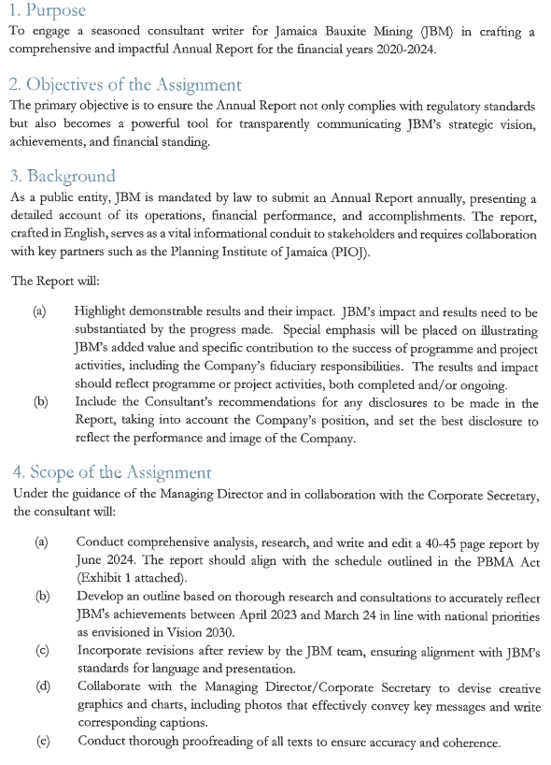

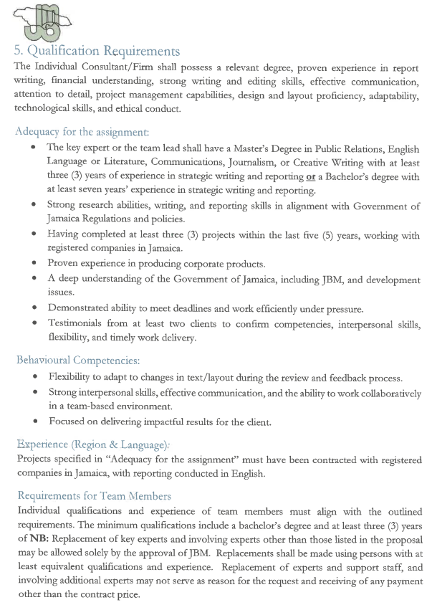

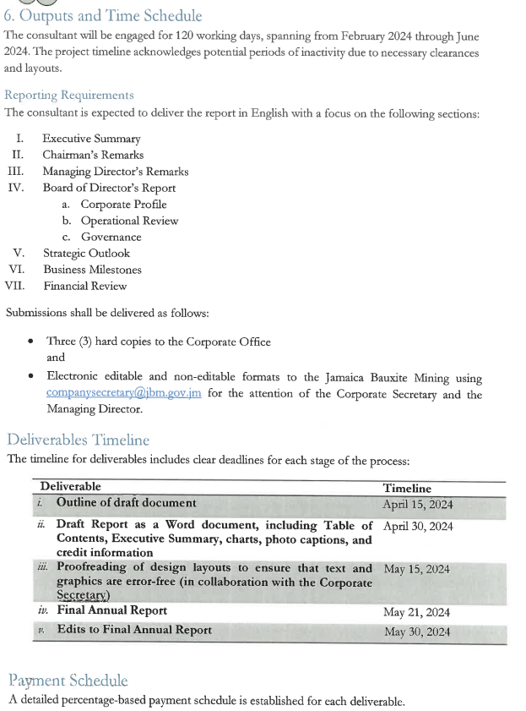
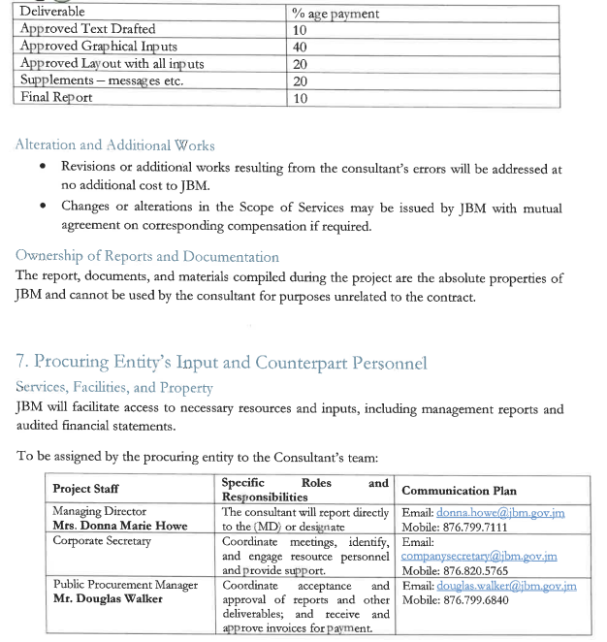

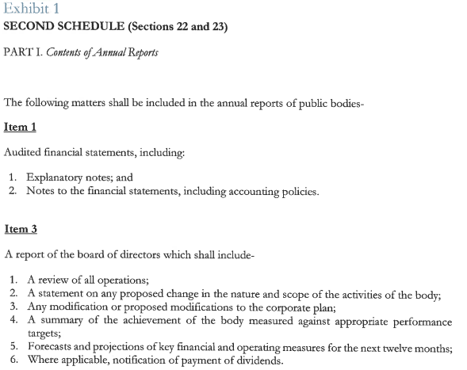

Section 2A Evaluation and Qualification Criteria
This Section contains all the criteria that the procuring entity shall use to evaluate bids and qualify bidders. In accordance with ITB Clauses 35 to 38, no other factors, methods or criteria shall be used. The bidder shall provide all the information requested in the forms included in Section IV, Bidding Forms.
Contents
Evaluation Criteria
No. | Requirements | Yes | No
 | ELIGIBILITY CRITERIA – Stage 1
1 | Copy of valid TRN or Tax Compliant Certificate/Letter (where applicable)
NB - Should the Bidder not be compliant with the above requirement; their bid will be declared non-responsive and rejected.
 | MANDATORY REQUIREMENTS - Stage 2 | Pass | Fail
1 | Signed Letter of Quotation on Company’s Letterhead or stamped
2 | General Proposal document showing methodology
3 | Curriculum Vitae (CV)

NB – 1) The Bidder must score at least 60 to be considered for Financial Evaluation
2) The bidders (s) who are substantially responsive, have met the mandatory requirements, attained a Technical score of 60 will be shortlisted for interview.

Section 3 Letter of Quotation
Date: ________________________
Ref No.: ______________________
To: JBML NCB 2024-03-22 ADM/11
I, the undersigned, declare that:
- I have examined and have no reservations to the Invitation, including Addenda issued in accordance with Instructions to Consultants/Firms (ITC/F);
- I offer to supply, in conformity with the Invitation for Quotations, the following services: ;
- The total price of our quotation, excluding any discounts offered in item (d) below, but including all applicable taxes is:
[amount of Jamaican Dollars in words], [amount in figures], ;
- The discounts offered and the methodology for their application are: ;
- Our quotation shall be valid for a period of _________days from the date fixed for the quotation submission deadline in accordance with the Request for Quotations and it shall remain binding upon us and may be accepted at any time before the expiration of that period;
- I do not have any conflict of interest in accordance with ITC/F 1;
- I have not been declared ineligible procuring entity in accordance with ITC/F 2 ;
- I hereby agree that in competing for (and, if the award is made to me, in executing) the contract, I undertake to observe the laws against fraud and corruption, including bribery, in force in Jamaica;
- We have paid all taxes, duties, fees and other impositions as may be levied in Jamaica and attach a copy of out TCL to this Form.
- The following commissions, gratuities, or fees have been paid or are to be paid with respect to the quotation process or execution of the contract:
Name of Recipient | Address | Reason | Amount
[If none has been paid or is to be paid, indicate “none.”]
- I understand that this quotation, together with your written acceptance thereof included in your notification of award, shall constitute a binding contract between us, until a formal contract is prepared and executed.
- I understand that you are not bound to accept the lowest responsive quotation or any other quotation that you may receive. I understand that the procuring entity may cancel a procurement at any time prior to the acceptance of the successful quotation or after the successful quotation is accepted if
(i) the Consultant/Firm presenting the quotation is disqualified under the Act or the regulations of the Public Procurement Act, 2015;
(ii) the procurement is cancelled;
(iii) the Consultant/Firm presenting the successful quotation is excluded on the grounds of corruption, unfair competition and a conflict of interest; or
(iv) the procurement, the quotation or the Individual Consultant/Firm contravenes or is otherwise not compliant with the provisions of the Public Procurement Act, 2015.
Name _________________________________ In the capacity of ___________________
Signed
Dated on ________________________________ day of _________________________

Curriculum Vitae (CV)

Position Title and No. | [e.g., K-1, TEAM LEADER]
Name of Expert: | [Insert full name]
Date of Birth: | [day/month/year]
Country of Citizenship/Residence
Education: [List college/university or other specialized education, giving names of educational institutions, dates attended, degree(s)/diploma(s) obtained]
_________________________________________________________________________________
Employment record relevant to the assignment: [Starting with present position, list in reverse order. Please provide dates, name of employing organization, titles of positions held, types of activities performed and location of the assignment, and contact information of previous clients and employing organization(s) who can be contacted for references. Past employment that is not relevant to the assignment does not need to be included.]
Period | Employing organization and your title/position. Contact information for references | Country | Summary of activities performed relevant to the Assignment
[e.g., May 2005-present] | [e.g., Ministry of ……, advisor/Individual Consultant to…  For references: Tel…………/e-mail……; Mr. Bbbbbb, deputy minister]
Membership in Professional Associations and Publications:
______________________________________________________________________
Language Skills (indicate only languages in which you can work):
______________________________________________________________________
Adequacy for the Assignment:
Detailed Tasks Assigned on Consultant’s Team of Experts: | Reference to Prior Work/Assignments that Best Illustrates Capability to Handle the Assigned Tasks [to include contact name and email address for each Client]
[List all deliverables/tasks in which the Expert will be involved)

Experts contact information:
[address ………………….., e-mail…………………., phone……………]
Certification:
I certify that to the best of my knowledge and belief, this CV correctly describes myself, my qualifications, and my experience. I confirm that I will be available to carry out the assignment for which my CV has been submitted in accordance with the implementation arrangements and schedule set out in the quotation. I understand that any misstatement or misrepresentation described herein may lead to my disqualification or dismissal by the procuring entity, and/or sanctions by the Government.
[day/month/year]

Name of the Individual Consultant/Firm Signature Date
[day/month/year]

 | Yes |  | No
(i) I am employed by the procuring entity
(ii) I was part of the team who wrote the terms of reference for this consulting services assignment
.

Client References
To: Jamaica Bauxite Mining Limited
[The Bidder shall provide a minimum of Two (2) client references for related contracts performed within the last five (5) years. The Bidder will provide the information in the suggested format below. Each client reference must be submitted under individual cover in a sealed envelope.]

Name of Organization: _________________________ Telephone: _________________
Name: ____________________________ Title: _______________________________
Address: _______________________________________________________________
Contract Period: _____________________________________________
Summary of project/engagement performed: ________________________________________________________________________________________________________________________________________________________________________________________________________________________________________________________________________________________________________________________
Performance Rating:
 | Excellent | Good | Poor
Competencies | ☐ | ☐ | ☐
Interpersonal skills | ☐ | ☐ | ☐
Flexibility | ☐ | ☐ | ☐
Timely Work Delivery | ☐ | ☐ | ☐
Please check ☒ the relevant column above
Other Comments:
__________________________________________________________________________________________________________________________________________________________________________________________________________________________________________________________________________________________________________________________________________________
Signed: ____________________________ Date: _______________________

NB – To be valid, this Client Reference form must be signed and stamped by the respective Client.
Section 4 Form of Contract Agreement
Contract for Consultant’s consulting services

Contract No. ____________________________

between

[Name of the procuring entity]

and

[Name of the Individual Consultant/Firm]

Dated:

Form of Contract
This CONTRACT (the “Contract”) is made the [number] day of the month of [month], [year], between, on the one hand, [name of procuring entity] (the “procuring entity”) and, on the other hand, [name of Individual Consultant/Firm] (the “Individual Consultant/Firm”) for the provision of [include title of the consulting assignment/services] (the “consulting services”) described in the Terms of Reference in the Appendix A.
WHEREAS, the procuring entity has accepted the Individual Consultant’s/Firm quotation for the performance of the consulting services, and the Individual Consultant/Firm is capable and willing to perform said consulting services.
The procuring entity and the Individual Consultant/Firm (the “parties”) agree as follows:
- This Contract, its meaning, interpretation and the relation between the Parties shall be governed by the applicable law of Jamaica.
- The Contract is signed and executed in the English language, and all communications, notices and modifications related to this Contract shall be made in writing and in the same language.
- The total Contract price is JMD [insert amount] and is [indicate: inclusive or exclusive. of local indirect taxes. The Contract price breakdown is provided in Appendix C.
- The expected date for the commencement of the consulting services is [insert date, month and year] at [insert location]. The time period shall be [insert time period, e.g.: twelve months].
- The procuring entity designates [insert the name and title] as procuring entity’s coordinator for the purpose of coordination of activities with the Individual Consultant/Firm under this Contract.
- Any dispute, controversy or claim arising out of, or relating to this Contract or the breach, termination or invalidity thereof, shall be settled by [dispute resolution in accordance with the applicable law] or [arbitration in accordance with the [insert applicable arbitration rules, e.g., UNCITRAL, ICC, national rules governing arbitration] as in force and effect on the date of this Contract]].
- The following documents form an integral part of this Contract:
- The General Conditions of Contract;
- Appendices:
Appendix A: Terms of Reference and Reporting Requirements
Appendix B: Key Experts
Appendix C: Breakdown of Contract Price
SIGNED:
For and on behalf of [Name of procuring entity]
[Authorized Representative of the procuring entity – name, title and signature]
For and on behalf of [Name of Individual Consultant/Firm]
[Individual Consultant/Firm –signature]
General Conditions of Contract

- General Provisions
- Definitions
- Unless the context otherwise requires, the following terms whenever used in this Contract have the following meanings:
- “Expert” means the Individual Consultant/Firm.

- Eligibility
It is the Individual Consultant/Firm’s responsibility to ensure that meets the eligibility requirements throughout the implementation of this Contract as established by the Government of Jamaica.

- Fraud and Corruption and Prohibited Practices
The Government of Jamaica requires that all parties involved in the procurement proceedings and execution of such contracts observe the highest standard of ethics.
For the purposes of this provision, offences of fraud and corruption are defined in Part VI of the Public Procurement Act, 2015 (Act) and any other Act relating to corrupt activities in Jamaica.
A person who commits an offence under the Act or any other Act relating to corrupt activities in Jamaica shall ---
  - be liable for conviction under the provisions of the Act or any other Act relating to corrupt activities in Jamaica;
  - have their quotation rejected if it is determined that the Individual Consultant/Firm is not in compliance with the provisions of the Act, the regulations or any other Act relating to corrupt activities in Jamaica;
  - risk other sanctions provided for in the Act or the regulations.

- Commissions and Fees Disclosure
- The procuring entity requires the Individual Consultant/Firm to disclose any commissions, gratuities or fees that may have been paid or are to be paid to agents or any other party with respect to the selection process or execution of the Contract. The information disclosed must include at least the name and address of the agent or other party, the amount and currency, and the purpose of the commission, gratuity or fee. Failure to disclose such commissions, gratuities or fees may result in termination of the Contract and/or sanctions by the Government of Jamaica.

- Force Majeure
- Definition
- For the purposes of this Contract, “Force Majeure” means an event which is beyond the reasonable control of a Party, is not foreseeable, is unavoidable, and makes a Party’s performance of its obligations hereunder impossible or so impractical as reasonably to be considered impossible under the circumstances, and subject to those requirements, includes, but is not limited to, war, riots, civil disorder, earthquake, fire, explosion, storm, flood or other adverse weather conditions, strikes, lockouts or other industrial action, confiscation or any other action by Government agencies.
- Force Majeure shall not include insufficiency of funds or failure to make any payment required hereunder.
- No Breach of Contract
- The failure of a Party to fulfill any of its obligations hereunder shall not be considered to be a breach of, or default under, this Contract insofar as such inability arises from an event of Force Majeure, provided that the Party affected by such an event has taken all reasonable precautions, due care and reasonable alternative measures, all with the objective of carrying out the terms and conditions of this Contract.
- Measures to be Taken
- A Party affected by an event of Force Majeure shall continue to perform its obligations under the Contract as far as is reasonably practical, and shall take all reasonable measures to minimize the consequences of any event of Force Majeure.
- A Party affected by an event of Force Majeure shall notify the other Party of such event as soon as possible, and in any case not later than fourteen (14) calendar days following the occurrence of such event, providing evidence of the nature and cause of such event, and shall similarly give written notice of the restoration of normal conditions as soon as possible.
- Any period within which a Party shall, pursuant to this Contract, complete any action or task, shall be extended for a period equal to the time during which such Party was unable to perform such action as a result of Force Majeure.
- During the period of their inability to perform the consulting services as a result of an event of Force Majeure, the Individual Consultant/Firm, upon instructions by the procuring entity, shall either:
- demobilize, in which case the Individual Consultant/Firm shall be reimbursed for additional costs they reasonably and necessarily incurred, and, if required by the procuring entity, in reactivating the consulting services; or
- Continue with the consulting services to the extent reasonably possible, in which case the Individual Consultant shall continue to be paid under the terms of this Contract and be reimbursed for additional costs reasonably and necessarily incurred.

- Suspension
- The procuring entity may, by written notice of suspension to the Individual Consultant, suspend part or all payments to the Individual Consultant/Firm hereunder if the Individual Consultant/Firm fails to perform any of its obligations under this Contract, including the carrying out of the consulting services, provided that such notice of suspension (i) shall specify the nature of the failure, and (ii) shall request the Individual Consultant/Firm to remedy such failure within a period not exceeding seven (7) calendar days after receipt by the Individual Consultant/Firm of such notice of suspension.

- Termination
- This Contract may be terminated by either Party as per provisions set below:
- By the procuring entity
- The procuring entity may terminate this Contract with at least fourteen (14) calendar days prior written notice to the Individual Consultant/Firm after the occurrence of any of the events specified in paragraphs (a) through (d) of this Clause:
- If the Individual Consultant/Firm does not remedy a failure in the performance of its obligations under the Contract after being notified by the procuring entity in writing by specifying the nature of the failure and requesting to remedy it within at least ten (10) calendar days after the receipt of the procuring entity’s notice;
- If the Individual Consultant/Firm becomes insolvent or bankrupt;
- If the Individual Consultant/Firm, in the judgment of the procuring entity, has engaged in fraud and corruption or prohibited practices as defined in Attachment 1 in competing for or in performing the Contract;
- If the procuring entity, in its sole discretion and for any reason whatsoever, decides to terminate this Contract.
- By the Individual Consultant/Firm
- The Individual Consultant/Firm shall promptly notify the procuring entity in writing of any situation or any event beyond the reasonable control of the Individual Consultant/Firm, which makes it impossible for the Individual Consultant/Firm to carry out its obligations under the Contract.
- Upon written confirmation by the procuring entity or upon failure of the procuring entity to respond to such notice within 14 (fourteen) calendar days of receipt thereof, the Individual Consultant/Firm shall be relieved from all liability and may thereupon terminate the Contract by giving no less than fourteen (14) calendar days a written termination notice.

- Obligations of the Individual Consultant/Firm
- Standard of Performance
- The Individual Consultant/Firm shall carry out the consulting services with due diligence and efficiency, and shall exercise such reasonable skill and care in the performance of the consulting services as is consistent with sound professional practices.
- The Individual Consultant/Firm shall act at all times so as to protect the interests of the procuring entity and shall take all reasonable steps to keep all expenses to a minimum, consistent with sound professional practices.
- Compliance
- The Individual Consultant/Firm shall perform the consulting services in accordance with the Contract and the Applicable Law and shall take all practicable steps to ensure they comply with the applicable law.
- Conflict of Interest
- The Individual Consultant/Firm shall hold the procuring entity’s interests paramount, without any consideration for future work, and strictly avoid conflict with other assignments or their own corporate interests.
- The Individual Consultant/Firm agrees that, during the term of this Contract and after its termination, the Individual Consultant/Firm shall be disqualified from providing goods, works or non-consulting services resulting from or directly related to the Individual Consultant’s/Firm’s consulting services for the preparation or implementation of the project.
- The Individual Consultant/Firm shall not engage either directly or indirectly, in any business or professional activities that would conflict with the activities assigned to them under this Contract.
- The Individual Consultant/Firm has an obligation to disclose any situation of actual or potential conflict that impacts their capacity to serve the best interest of their procuring entity, or that may reasonably be perceived as having this effect. Failure to disclose said situations may lead to the disqualification of the Individual Consultant/Firm or the termination of its Contract.

- Confidentiality
- Except with the prior written consent of the procuring entity, the Individual Consultant/Firm shall not at any time communicate to any person or entity any confidential information acquired in the course of the services, nor shall the Individual Consultant/Firm make public the recommendations formulated in the course of, or as a result of, the services.

- Insurance to be Taken by the Individual Consultant/Firm
- The Individual Consultant/Firm shall take out and maintain at its own cost adequate professional liability insurance as well as adequate insurance against third party liability and loss of or damage to equipment purchased in whole or in part with funds provided by the procuring entity. The Individual Consultant/Firm shall ensure that such insurance is in place prior to commencing the consulting services.
- The procuring entity undertakes no responsibility in respect of any life, health, accident, travel or other insurance which may be necessary or desirable for the Individual Consultant/Firm for purpose of the consulting services, nor for any dependent of any such person.
- The procuring entity reserves the right to require original evidence that the Individual Consultant has taken out the necessary insurance.

- Accounting, Inspection and Auditing
- The Individual Consultant/Firm shall keep accurate and systematic accounts and records in respect of the consulting services and in such form and detail as will clearly identify relevant time changes and costs.
- The Individual Consultant/Firm shall permit the procuring entity and/or persons appointed by the procuring entity to inspect the site and/or all accounts and records relating to the performance of the Contract and the submission of the quotation to provide the consulting services, and to have such accounts and records audited by auditors appointed by the procuring entity.

- Reporting Obligations
- The Individual Consultant/Firm shall submit to the procuring entity the reports and documents specified in Appendix A, in the form, in the numbers and within the time periods set forth in said Appendix.

- Proprietary Rights of the procuring entity in Reports and Records
- All reports and relevant data and information such as maps, diagrams, plans, databases, other documents and software, supporting records or material compiled or prepared by the Individual Consultant/Firm for the procuring entity in the course of the consulting services shall be confidential and become and remain the absolute property of the procuring entity unless otherwise agreed by the procuring entity in writing. The Individual Consultant/Firm shall, not later than upon termination or expiration of this Contract, deliver all such documents to the procuring entity, together with a detailed inventory thereof.
The Individual Consultant/Firm may retain a copy of such documents, data and/or software but shall not use the same for purposes unrelated to this Contract without prior written approval of the procuring entity.

- Description of Individual Consultant
- The title, agreed job description, minimum qualification and estimated period of engagement to carry out the consulting services of the Individual Consultant/Firm are described in Appendix B.

- Procuring entity’s Payment Obligation
  - In consideration of the consulting services performed by the Individual Consultant/Firm under this Contract, the procuring entity shall make such payments to the Individual Consultant for the services specified in Appendix A and in such manner as described in Appendix C.

- Mode of Billing and Payment
  - The payments under this Contract shall be made in accordance with the payments provisions in Appendix C.
  - Payments do not constitute acceptance of the whole consulting services nor relieve the Individual Consultant/Firm of its obligations.

- Amicable Settlement
  - The procuring entity and the Individual Consultant/Firm shall make every effort to resolve amicably by direct informal negotiation any disagreement or dispute arising between them under or in connection with the contract.
  - If, after twenty-eight (28) days, the parties have failed to resolve their dispute or difference by such mutual consultation, then either the procuring entity or the Individual Consultant/Firm may give notice to the other party of its intention to commence arbitration, as hereinafter provided, as to the matter in dispute, and no arbitration in respect of this matter may be commenced unless such notice is given. Any dispute or difference in respect of which a notice of intention to commence arbitration has been given in accordance with this Clause shall be finally settled by arbitration. Arbitration may be commenced prior to or after delivery of the goods under the contract. Arbitration proceedings shall be conducted in accordance with the rules of procedure specified in para 6 of the Contract Form.
  - Notwithstanding any reference to arbitration herein,
  - the parties shall continue to perform their respective obligations under the contract unless they otherwise agree; and
  - the procuring entity shall pay the Individual Consultant/Firm any monies due the Individual Consultant/Firm.

Appendices
Appendix A – Terms of Reference and Reporting Requirements
- Background
[Insert text]
- Objective(s) of the Assignment
[Insert text]
- Scope of consulting services, Tasks (Components) and Expected Deliverables
- [insert detailed description or provide a summary here and attached a detailed description at the end]
- [indicate if downstream work is required]
- [indicate if training is a specific component of the assignment]
- Qualification Requirements for the Individual Consultant/Firm
[insert the name of the Individual Consultant/Firm and describe qualification requirements]
- Reporting Requirements and Time Schedule for Deliverables
[At a minimum, list the following:
- language, format, frequency, and contents of reports;
- number of copies, and requirements to electronic submission (or on CD ROM). Final reports shall be delivered in CD ROM in addition to the specified number of hard copies;
- dates of submission;
- persons (indicate names, titles, submission address) to receive them; etc.
- If no reports are to be submitted, state “Not applicable.”
If the consulting services consist of or include the supervision of civil works, the following action that require prior approval by the procuring entity shall be added: “Taking any action under a civil works contract designating the Individual Consultant/Firm as “Engineer”, for which action, pursuant to such civil works contract, the written approval of the procuring entity as “procuring entity” is required.”]
- Procuring entity’s Input, Counterpart Personnel and Location of consulting services
- Individual Consultant/Firm shall provide consulting services at the following location(s): [insert location]
- Consulting services, facilities and property to be made available to the Individual Consultant/Firm by the procuring entity: [list/specify/ or state “none”]
- Ensure that the Individual Consultant/Firm has access to wherever it is required for the performance of the consulting services at the location(s) mentioned above.
- Professional and support counterpart personnel to be assigned by the procuring entity to the Individual Consultant’s/Firkm’s team: [list/specify]
- The authorized representative of the procuring entity during the implementation of this Contract is: [insert name, job title and contact information]

Payment Terms

TOTAL CONTRACT AMOUNT - LUMP SUM CONTRACT
(3A) Schedule of Payments for Deliverables: [insert detailed list of payments specifying amount of each instalment, deliverable/output for which the instalment is paid and currency] |  | Currency | Amount
1. | 1st Payment for [Deliverable 1: ……………..]
2. | 2d Payment for [Deliverable 2 ……………...]
n. | (3B) Indirect Local Taxes paid by [insert “procuring entity” OR “Individual Consultant”]

Payment Terms
The procuring entity will pay an invoice for each deliverable which must be supported by evidence of acceptance of the deliverable.

