Jamaica Bauxite Mining Limited

REQUEST FOR PROPOSAL

Terms of Reference

Joint Venture Partnership and/or
Financial Structure Proposal
for the Development of JBM’s Mixed Use- Commercial Park and the Orange Park Housing Development Projects.

Background and Objectives

Company Profile
Jamaica Bauxite Mining (JBM) Limited is a government-owned Company (a public body) with a business enterprise mandate. The Jamaica Bauxite Mining Limited (JBM) is currently an agency of the Ministry of Agriculture, Fisheries and Mining was incorporated on February 13, 1975. It holds 51% equity on behalf of the Government of Jamaica in the bauxite operations, Discovery Bauxite Partners (Formerly Noranda Jamaica Bauxite Partners). JBM is the custodian and monitors the operations of the partnership in which it holds equity, on behalf of the government of Jamaica to ensure the Government’s return on investments is maximized.
JBM’s non-bauxite activities include the Port Operations and Management of the Reynold’s Pier located in Ocho Rios. Industrial water supply, Commercial Property management and maintenance of the vast 4,000 acres of land on the Lydford Estate in the parish of St. Ann.

Procurement Scope - Financial Structure Proposal:
JBM in accordance with the Financial Administration and Audit Act (FAA) Act, the Medium-Term Debt Management Strategy (MTDS) for the financial year 2023/2024 governed by the Public Debt Management Act (PDMA), and in accordance with the Debt Management Policy of the Ministry of Finance and the Public Service (MOFPS), is now Issuing a Request for Proposal to obtain a Financial Proposal for Joint Venture Partnership(s) and/or a Financial Proposal on the appropriate financial structure to put in place, in the financing of two (2) strategic infrastructure projects.
Infrastructure Projects
JBM’s strategic direction seeks to explore revenue streams opportunities. A part of that viability effort is to optimize its assets as well as diversify and identify more reliable revenue sources. In keeping with the aforementioned thrust, JBM has decided to embark on a number of projects, two (2) of which are as under:
- Commercial Park
The development and construction on a 65-acre property with 280,000sq. ft Commercial Park which will include a Business or Knowledge Process Outsourcing (BPO/KPO), commercial shops, food court different sized warehouses and an Auditorium, training centre/homework centre. The proposed Commercial Park will make available a rentable space of 272,540 sq. ft., to include the following:

- Lot A: BPO/Technology Park – 63,000 sq. ft
- Lot B: 24 Commercial Shops – 28,300 sq. ft.
- Lot C: 31 Mini Warehouses - 53,940 sq. ft.
- Lot D: 10 Medium Warehouses – 30,000 sq. ft.
- Lot E: 5 Large Warehouses – 88,000 sq. ft.
- Lot F: Auditorium / Training Centre – 9,300 sq. ft.

For the preparation and/or evaluation of Proposals, the following financial information may be assumed:

- The Construction cost/order-of-magnitude is JMD$3.2 billion
- The time/duration for construction is estimated to take 12 to 18 months.
- Revenue is estimated at JMD 308 million dollars per annuum with additional maintenance cost per annum.

- Housing Development
A Housing Development consisting of approximately 750 dwelling lots/houses of 4,000 - 6,500 sq. ft each having green areas and all supporting infrastructure. The Housing Development project is intended to develop a new community with homes and interrelated open space and recreation amenities. The design of the complex will integrate an interrelated open space system including a greenbelt with walking trails, and landscape areas, in addition to active recreation facilities, to facilitate an active and healthy lifestyle for residents.

For the preparation and/or evaluation of Proposals (i.e. Project financial arrangements, etc.) please be advised that a feasibility study is not yet done and so the development cost which is not yet ascertained, may be assumed. The time/duration for construction and delivery of houses are also to be determined.
With respect to both projects above, the JBM has earmarked a 65-acre lot for the Commercial Park Complex and an additional 150-acres for the Housing Development. These land parcels are located in Lydford, Golden Grove in the parish of St. Ann. The proposed location is less than five minutes from the North South Highway, approximately 40 minutes to Kingston and 10 minutes into Ocho Rios. This provides easy access to commerce activities. Additionally, there is the constant need for housing accommodation and a great demand for warehouse spaces as well as for Business/Knowledge Process Outsourcing (BPO/KPO)/Technology Park operations.
Both projects are aligned to the strategic objectives of the government and will be implemented through the Public Sector Investment Programme with regards to the fiscal and debt sustainability, prevailing socio-economic and environmental conditions; and to the implementation status and technical capacity of this and other related executing agencies.

The Financial Proposal for Joint Venture Partnership and/or Proposed Financial Structure
The aim of this request for proposal is to receive a proposal that will outline the Proposed Joint Venture Partnerships and/or Proposed Financial Structure options that will best enable the JBM to successfully implement the two infrastructure development projects named above. The JBM seeks to obtain a proposal for Joint Venture Partnership from an Entity/organization and/or a Financial Institution that outlines and will be able to finance through a financing vehicle and projectized structure the financing and/or financial options for JBM’s two Developmental infrastructure Projects, whether as straight Financiers, Joint Partnerships and/or Equity Partners.
It is JBM’s intention to utilize a long-term project financing structure and arrangements that can ring-fence JBM’s existing assets and operation and to minimise and mitigate the financial risk and exposure.
The Proposal may include a mix of options of how funds, capital debt and/or equity is to be applied to finance the projects, especially with respect to how much debt and their repayment profile(s). The cost of debt for each debt instruments to be utilized and all rates, commitment fees to be charged to JBM, should be clearly disclosed within the Proposal.
The Proposed Joint Venture Partnership, Financial Structure and all financial arrangements suggestions must be cognizant of meeting and satisfying the GoJ Debt and Fiscal Management Policy and also the guidelines on Public Agency’s long-term equity & debt financing.
The Proposed Joint Venture Partnership, Financial Structure and all financial arrangements suggestions must be cognizant of meeting, satisfying and aligned to the JBM’s company and project objectives.
The company believes there will be value in the creating of a Special Purpose Vehicle (SPV) and now seek to forge strategic partnerships and have joint venture arrangements with credible entities and financial institutions. The Proposal should indicate the proposed structure of the SPV (the project company) and should illustrate the level of project debt/equity financing. Debt may be in the form of debt instrument, corporate or construction loans or bonds. Equity may take the form of pure equity or capital shares, and quasi-equity financial instruments or products.
The Proposal should also contain information with respect to administrative and facilitation arrangements for both projects.
The Proposal should also contain information with respect to both project’s financial projections, net income statement projections, cash flow projections, investment and evaluation data such as NPV, IRR and Payback periods, Loans/Commitment rates and/or interest rate/returns and recommended type of bond/shares, where deemed possible to provide this information and appropriate.
The proposal must be inclusive of all options/offerings/suggestions and/or recommendations; and must be in conformance with all Jamaica law, legal and regulatory requirements and satisfy GOJ policies.
Qualification of the Joint Venture Partner / Financial Institution
- The acceptable Financial Proposal/Framework and/or Deal Structure arrangements will be from an Organization or Firm or Financial Institution and not from individuals.

- The Proposal from the acceptable Joint Venture Partner / Financial Institution must include the following eligibility requirements:
- Valid copy of Certification of Registration/Incorporation
- Copy of Tax Compliance Letter (TCL)
- Evidence of Registration/Approval/Authorization within their respective Regulation or Act (Banking Services Act, Financial Institution Act, Building Society Act and/or by the Financial Services Commission Act).

- The Proposal must demonstrate evidence of Institution’s relevant experience:
- Proven-track record and experience in Joint Venture Partnerships and in the financing and execution of joint venture deals, financing structures and debt/equity corporate financing.
- In project management and/or business financing, financial models, financial feasibility analysis for existing and/or new projects, operations or services.
- Experience in Joint venture conceptualization of transactional structures and financing arrangements.
- Experience working with engagements with Government of Jamaica (GOJ) and other public bodies.
- At least two (2) engagements in the last 10 years related to negotiation of financial arrangements and/or deal structuring.
- Other information about the Institution or Financial Institution in terms of size and Financial Stability, should be available.

Team Qualifications and Experience:
It will be required that an experienced team be compilated who will have demonstrated a proven track-record of team competence and experience.
- Team Composition & Qualification Requirements for the Key Financiers:
Experience personnel: proven track record and experience in executing Financing Structure, they will show requisite proficiencies with at least three (3) years’ experience in the area of Joint Venture Partnerships, corporate banking or financial consultancy.
- Team Composition & Qualification Requirements for the Key practitioners:
Experience personnel: proven track record and experience in preparing documentation and executing transactional and deal structures in the area of Joint Venture Partnerships and of value would be relating to engagements related to business formation & financing.

Project Timeline Schedule
The two projects have already received Public Investment Appraisal Branch (PIAB) concept approvals and the joint venture partnership, financial structure and/or arrangements for funding the projects is now a requisite requirement for the establishment of the SPV and for full approval and implementation of the projects.
Full Project approval by the GOJ arm, within PIAB is anticipated within a four to six (4-6) month timeframe, therefore there is some urgency in obtaining Joint Venture Partners and finalizing a suitable financial structure and/or future Deal Structure arrangements, in financing for BOTH projects.

The Joint Venture Partner / Financial Institution will be expected to work with the JBM:
The selected Joint Venture Partner / Financial Institution will be required to work with the JBM in providing the requisite information, market financial options, support, documentation and arrangements, required for the successful financial execution and implementation of these two projects.
Attending briefings and have discussions with the JBM and other related internal and external stakeholders/participants.

JBM’s responsibility
JBM intends to screen the proposals for feasibility and consistency with government's fiscal objectives and ensure it captures and fulfil the projects technical, financial, economic and environmental feasibilities.
For the preparation of the final approved Financial Proposal and/or Capital Deal arrangements for Ministry approvals, the JBM will:
Provide access to all related records, feasibility reports, titles, commitments, Bills of Quantities (BQ), information that falls within the scope of the engagement to ensure the proper discharge of its obligations.
Make the necessary arrangements to ensure there is access to the necessary internal resources and inputs (contact personnel, documents, records, etc.) within the scope of the engagement to ensure the proper discharge of all services within the stipulated timeframe.
Make the necessary arrangements to ensure there is access to property locations where the Projects will be Constructed/Developed. The available internal personnel include:-
- Managing Director
- Financial Controller
- Company Secretary
- Project Manager
- Business Development and Marketing Manager
- Procurement Manager
JBM will make available to the selected Joint Venture Partner and/or Financial Institution:
- JBM’s Audited Financial Statement for the year-ended 31 March 2023.
- Access to all Project feasibility analysis and Market Demand Analysis Reports.
- Access to the PIAB submission package for approval. This will be done within the timeframe to be indicated at the commencement meeting.

The Joint Venture Partner / Financial Institution’s responsibility
The selected Joint Venture Partner / Financial Institution will further carry out financial risk assessments, due-diligence and competitive market analysis, to satisfy an acceptable financial model, framework and/or structure for the successful construction and financial viability of the two projects.
The selected Joint Venture Partner / Financial Institution will ensure that the proposed financial structure, framework or deal structure model reflects current markets, situational analysis and stress test models and ensuring that financial options, etc. can be so packaged in a format, suitable to approach investors, developers or/and prospect clients, if required.
To assist JBM in the preparation and submission of the legal and regulatory required documents, forms and/processes for:
- GOJ, Cabinet Approval,
- Incorporating the SPV
- Effectuating the Transactional Structure, Financial Structure, the SPV and the Financing instrument(s) of both Projects.
- Investor/Developer pitches and prospectus
Upon approval of the establishment of the SPV, to assist JBM in the implementation of both projects and the rolling-out of agreed financial arrangements and/or Deal Structure or arrangements.
Add Value:
The consultant is at liberty to make further recommendations and suggestions that will add value to the TOR requirements that fulfils any area or sections within the TOR, over and beyond the basic requirements as they deem fit.
Other Pertinent Factors to note:
- The GOJ continues to monitor and encourages the use of Public Private Partnerships and Joint Venture relationships within the Government Agencies.
- The GOJ continues to monitor the relative costs and risks of the debt portfolio to assess the consistency of debt operations with the Government Agencies.
- Interest rate risk refers to the change in debt service cost arising from the variability in interest rates.
- There should be a focus on market risks relating to potential changes in the exchange rate, interest rate foreign currency risk, inflation risks, credit risk as well as refinancing risks.
- The Government has placed a focus on limiting and keeping within limits of government guarantees, thus limiting any financing structure that is a contingent liability in the form of government guarantees.
- The GOJ are seeking initiatives to de-dollarize the debt portfolio by exploring the feasibility of issuing local currency-denominated debt.
- When considering terms of maturity and diversity of instruments, the impact of the cost of financing should be stated, where applicable.
- The risk profile of the company (JBM) must be considered.
- Of essence to note, all Joint Venture Partnerships, financing arrangements, traditional and any non-traditional financial structure, must be approved by the MOFPS.

Presentation of Financial and Future Reports
- The Joint Venture Proposal / Project Financing Proposal, with all eligibly/required documents and information should be submitted within the stipulated date and time in hard copy and an electronic non-editable form to:
Mr. Douglas Walker
Procurement Manager
Email address: - douglas.walker@jbm.gov.jm
Jamaica Bauxite Mining Limited
Reynolds Pier, Ocho Rios
St. Ann.
- Upon engagement of a Joint Venture Partner/Financial Institution financial structure, all subsequent reports, etc. should be submitted within agreed timelines in hard copy and an electronic non-editable form to:
Mrs. Donna Marie Howe
Managing Director
Email address: - donna.howe@jbm.gov.jm
Jamaica Bauxite Mining Limited
Reynolds Pier, Ocho Rios,
St. Ann.
Expected reports and deliverables must be prepared in accordance with applicable banking, accounting and legal standards and other related terms of reference.

Attached is the Project Brief which has an outline of the two projects.

Disclaimer
The proposal content is non-binding. The proposal will be used solely for the purpose of the Jamaica Bauxite Mining Limited to make a selection in connection of the aforesaid caption.
-END

Appendix 1 – PROJECT BRIEF

JBM PROJECTS BRIEF
Commercial Park & Orange Park Housing Development

Jamaica Bauxite Mining Ltd.
PCJ Resource Centre, Ground Floor
36 Trafalgar Road, Kgn 10, &
Reynolds Pier, Ocho Rios, St. Ann
(876) 926 4555; 974 4317
website:www.jbm.gov.jm

1. JBM Land Development Projects
1.1 Overview & Background
JBM’s strategic direction seeks to explore more revenue opportunities. Revenues gained from the export of sugar, through JBM’s port has significantly declined in recent years. In 2012/13 financial year, an average of 81,000 metric tonnes of sugar shipped through the ports. This has declined precipitously to an average of 6000 tonnes in 2020, which meant the almost total erosion of one revenue stream. With diminishing revenue streams, and the continued changes in the operating environment, the need to manage risks, require the Company to take steps to remain viable. A part of that viability effort is to optimize its assets as well as diversify and identify more reliable revenue sources. In keeping with the aforementioned thrust, JBM has decided to embark on the following projects:

- A 260,000 sq. ft Commercial Park which will include a BPO/KPO, commercial shops, different sized warehouses and a clubhouse/homework centre.

- Orange Park Housing Development consisting of 500 dwelling lots/houses of 4,000 -6,500sq ft each having green areas and all supporting infrastructure.

1.2 Project Impact Statement
The project is aim at achieving the following:
- Economic Growth:
  - Optimization of Government Assets (Mined-out lands)
  - Sustainability of JBM
  - Economic development in the community
  - Increased income generating possibilities for people within the community
  - Increased confidence in the business community (model commercial park) – attracting other developments/investors.

- Job Creation:
  - Increased Employment Opportunities: Direct and indirect job creation for over 1600 people
  - Job creation for skilled workers and university graduates

- Increased Skills Labour Certification
  - JBM plans to provide educational support in collaboration with HEART to verify and certify workers so they can take up opportunities when the project is completed.

- Rural Development
  - Infrastructure development
  - Retention of skilled workforce and tertiary graduates
  - Responding to BPO sector and Warehouse shortage
  - Renewable energy sources will be used
  - Environmental and Social impact

- Housing Solutions through the provision of 500 Housing Solutions to support:
  - Existing demand for residential housing
  - The growth and expansion of the area

2. Commercial Park Project
Diagram 1 – Showing Proposed Location for the Commercial Park Project
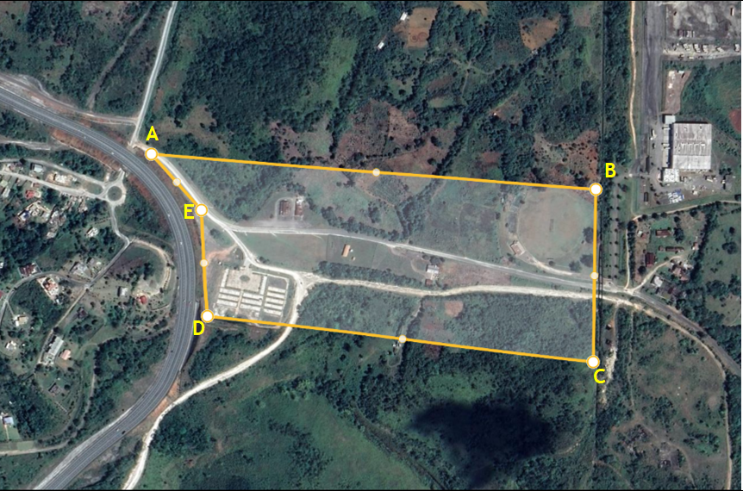
Diagram 2 – Showing Schematic Design for the Commercial Park Project
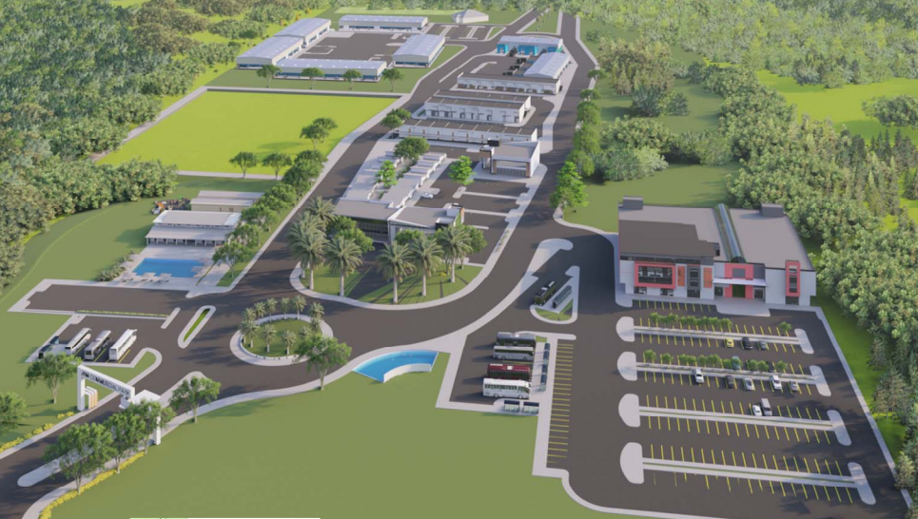
2.1 Project Description

2.1.1 Background
JBM has earmarked a 65 acre lot within the parish of St. Ann, in the Lydford Estate, Golden Grove area for the Development of the Commercial Park Complex. The proposed location is less than five minutes from the North South Highway, approximately 40 minutes to Kingston and 10 minutes into Ocho Rios. This provides easy access to commerce activities. Additionally, there is a great demand for warehouse spaces as well as for Business/Knowledge Process Outsourcing (BPO/KPO)/Technology Park operations. Lydford and Golden Grove also have the fibre optic and telecommunication infrastructure to support operations for a BPO/Technology Park as well as easy access to human resources through an ecosystem of high schools, community colleges, and universities in the parish.
The proposed project will redefine and enhance the community and support the development of new communities, create sustainable employment opportunities, utilize existing lands and provide increased Commercial Space. The proposed Commercial Park will make available a rentable space of 272,540 sq. ft., to include the following:
- Lot A: BPO/Technology Park – 63,000 sq. ft
- Lot B: 24 Commercial Shops – 28,300 sq. ft.
- Lot C: 31 Mini Warehouses - 53,940 sq. ft.
- Lot D: 10 Medium Warehouses – 30,000 sq. ft.
- Lot E: 5 Large Warehouses – 88,000 sq. ft.
- Lot F: Clubhouse/ Homework Center – 9,300 sq. ft.

2.1.2 Current Situation

- The results of the Geotechnical & Topography surveys have proved highly favorable for the proposed development.

- JBM owns two wells of total capacity 4075 cubic meters per day which are located in close proximity of the proposed development. These wells are intended to be used as the water resource for the Housing Development project

- Orange Park Housing Development Project

3.1 Project Description
3.1.1 Background
The Housing Development project is intended to develop a new community with homes and interrelated open space and recreation amenities on approximately 150 acres near existing and planned infrastructure, services, and jobs.
The proposed land parcel is able to accommodate over 1000 houses, however the first tier of the project is earmarked to for the construction of 500 affordable housing solutions along with all supporting infrastructure including road network, sewage treatment system, drains, MEP systems, designated green areas, park and recreational facilities.
The size of the proposed lots range from 4000 ft2 (two bedroom units) to 6000 ft2 (three bedroom units), depending on the number of habitable rooms per dwelling.
For the Orange Park Housing Development Project, the JBM will execute the required activities to achieve conditional approval.

Diagram 3 – Showing Proposed Location for the Housing Development Project
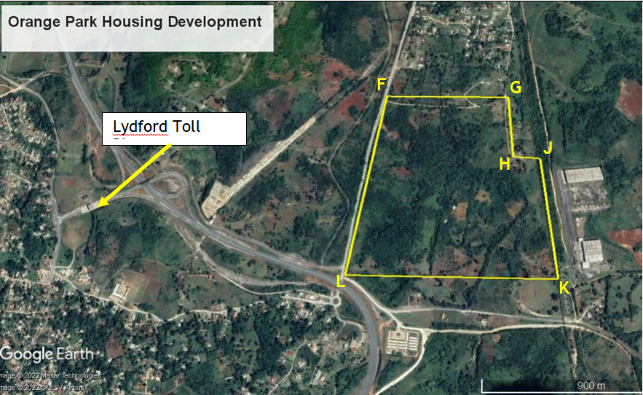

Diagram 4 – Showing Schematic Master plan for the Housing Development Project

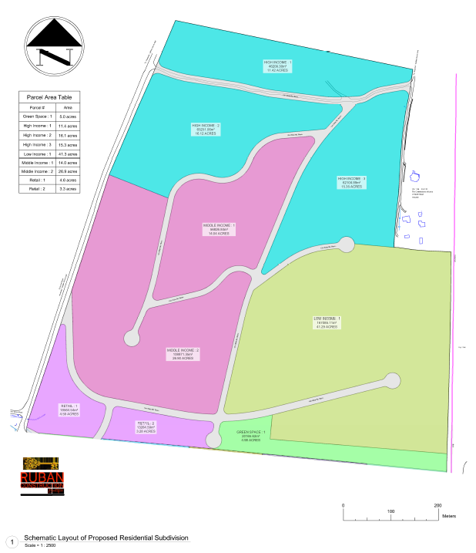

Appendix 2- INFORMATION SHEET
Name of Entity
(Joint Venture Partner /
Financial Institution):
Registered Address:
Date of Registration & Registration Number

ELIGIBILITY REQUIREMENTS
Type of Institution:
☐ Commercial Bank
☐ Building Society
☐ Investment House / Institutions
☐ Securities Dealers
☐ Brokers and Dealers
☐ Others

Compliance:
 | Compliance
 | Yes | No | N/A
Valid copy of Certification of Registration/Incorporation
Copy of Tax Compliance Letter (TCL)

 | Compliance
 | Yes | No | N/A
Authorized and regulated by the Banking Services Act
Authorized and regulated by the Financial Institution Act
Authorized and regulated by the Building Society Act
Authorized and regulated by the Financial Services Commission Act
Yes– Eligible No- Not Eligible N/A- Not Applicable

EVALUATION CRITERIA
Joint Venture Partnership and/or Financial Institution
Proposal

SECTION 1 - Eligibility Requirement | Compliant
 | Yes | No
Mandatory
Non-Mandatory
Evidence of Registration/Approval/Authorization within the required Regulation Act (Banking Services Act, Financial Institution Act, Building Society Act and/or by the Financial Services Commission Act).

Valid Copy of Certificate of Registration/ Incorporation

The did/proposal submission will not be rejected for the absence of non-mandatory documents but the procuring entity reserves the right to request same following the tender opening exercise/receipt of proposal.

Section 2. TECHNICAL CRITERIA –
Bidder must score a minimum of points to be considered for Financial Evaluation
 | Technical Criteria | Points | Actual Score
A, | Adequacy of the proposed methodology and work plan in responding to the Terms of Reference
Technical Approach and Methodology
  - Consultants are expected to explain their understanding of the assignment and its objectives, the issues and their importance and propose a technical approach that would be used to address them. Further, the consultants should propose a methodology that would be adopted and demonstrate its compatibility with the proposed technical approach.
Proposal
  - The consultants should propose the main activities of the assignment, content and duration, phasing and interrelations, milestones and implementation plans. The proposal/ work plan should be consistent with the proposed technical approach and methodology to demonstrate that the consultant fully understands the requirements of the TOR.

Add Value
  - Demonstration or illustration of where the consultant has made further recommendations and suggestions that will add value to the TOR requirements that fulfils any area or sections within the TOR, over and beyond the basic requirements as they deem fit.
Organization and Staffing
  - Based on the financing solution proposed, the consultants should propose the structure and composition of the team, including the roles and responsibilities of key experts along with the technical and support staff. An organizational chart should be provided to show the proposed work team based on the technical approach, methodology and work plan.
B | Quality of key experts’ Qualifications and Competence for the assignment  Points allocated as follows:  Education, training and experience as it relates to the specific assignment – 100%
 | Key staff must demonstrate requisite proficiencies with at least three (3) years’ experience in the area of corporate financial consultancy
Key staff should possess at least three (3) years’ experience on engagements related to business formation, financing, Deal Structure:
A list of at least 3 engagements should be provided (2.5 points each engagement)
C | Proposal Presentation
 | Intellectual and Technical Soundness
 | Organization and completeness
D | Organization’s Proven Experience  2 Similar assignments executed in the last ten (10) years related to negotiation and packaging of financial arrangements and/or deal structuring.  5 points per assignment.
- 2 similar assignments executed within the last 10 Years – 10 Points
- 1 similar assignment executed within the last 10 Years – 5 Points
E | Other Relevant Experience
- 1 to 5 projects with values between $J$1.0 - J$5 billion)
- 1 to 5 projects with values greater than J$5 billion –
 | Experience working on engagements with Government of Jamaica (GOJ) and other public bodies.
 | Evidence of experience in the financing and execution of corporate finance deals and financing structures.
 | Experience in project and/or business financing and financial modelling.
F | Organizational Structure  Demonstrated evidence that the Organization / Institution’s Organizational structures consists of:
 | Lines of Business include Banking, Financing, Wealth Management and Advisory Services
 | Investments, Fund Management & Portfolio Management
 | Involve in Mergers & Acquisitions; Deal Brokering & Financial Arrangements
G | Financial Position  Net Asset / Market Capitalization
 | Less than J$50M
 | $50M Up to $500M
 | More than $500M
 | TOTAL POINTS (max. 200)
 | Minimum Qualifying score ____ (__ points) of max points (200)
The minimum qualifying score is ___% of the total Technical points (200), any proposal receiving a scoring less than the minimum qualifying score may be rejected and those financial proposals may not be evaluated further.

